Case 10- Mex-Olmec-Were Jaguar-Pendant-Amphbolite-1200-900 BCE

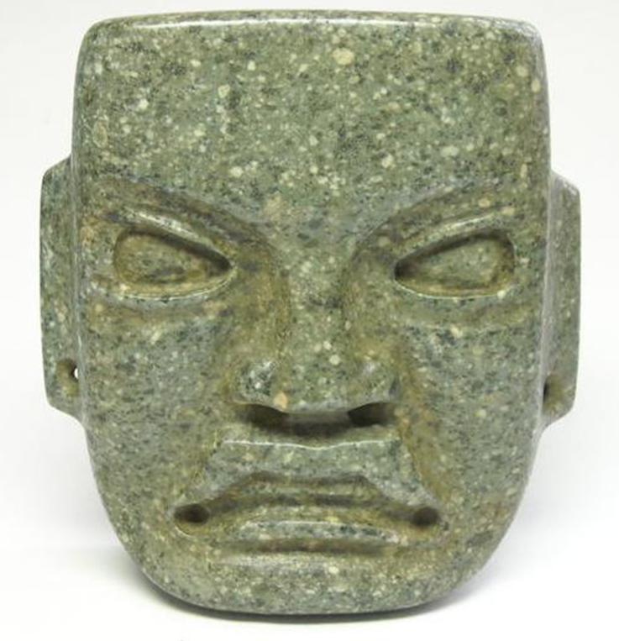

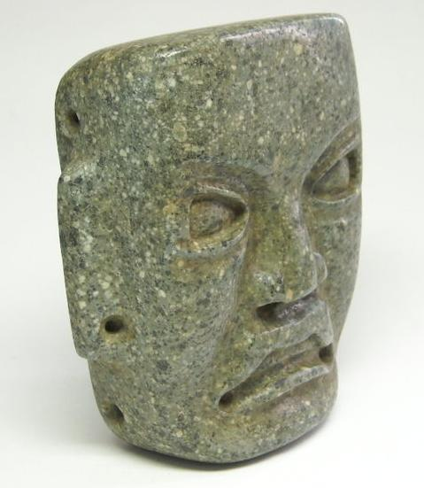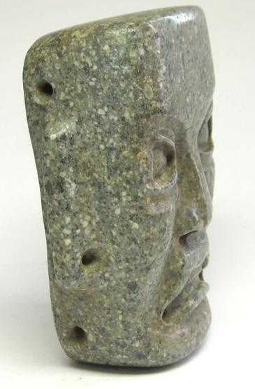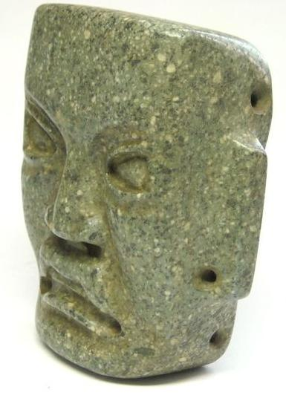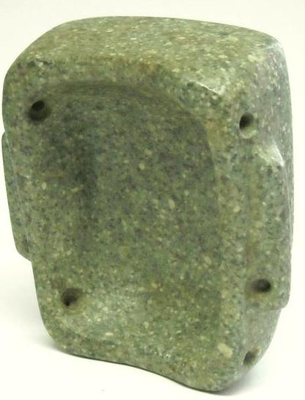

**Formal Label:** Olmec-Were Jaguar-Pendant-1200-900 BCE

**Accession Number:**

**LC Classification:**

**Display Description:**

This Olmec Were Jaguar pendant dates to the period 1200-900 BCE.

The mask is carved from grey-greenish amphibolite composed of amphibole dark colored prismatic crystals (with interlocking chains of silicate tetrahedra),and plagioclase feldspars. It is typically dark-colored and heavy, with small flecks of black and white giving it a salt-and-pepper appearance.

The mask features a rigidly rectilinear geometric portrait of a shaman being transformed into a jaguar spirit. He has a flared nose, up-curved upper lip which is intended to emulate the jaguar's snarl, as he bares a row of evenly filed teeth. Four holes, two drilled into the temples and two drilled into the cheeks, indicate that this was to be worn as a pendant on the chest and not as a mask, and this is confirmed since the eyes are not drilled. However, the pupils of the eyes have been expertly abraded to produce a visage at once powerful and terrifying as they gaze down on their on-looking subject. Two additional holes were drilled into the ear lobes to suspend earrings. A similar, rigidly rectangular maskette effigy plaque from Cuautla, Morelos, Mexico, is in the University of Maine Museum.

**LC Classification:**

**Date or Time Horizon:** 1100 BCE

**Geographical Area:** Cuautla, Morelos, Mexico

**Cultural Affiliation:** Olmec

**Map:**

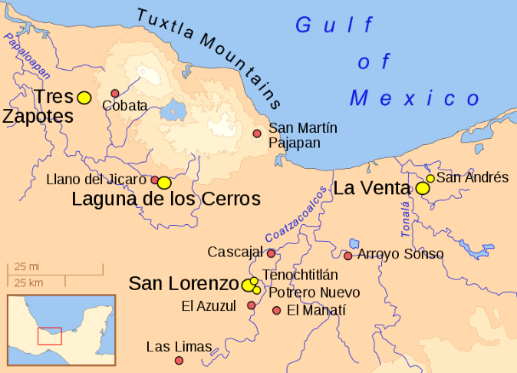

**GPS coordinates:**

**Cultural Affiliation:** Olmec

**Medium:** amphibolite

**Dimensions:**

**Weight:**

**Condition: original.**

**Provenance:**

**Discussion:**

The Olmecs, the earliest known settled civilization of Central America, lived in the low-lying Gulf Coast area of what is now Mexico in about 1200-400 BCE at sites such as San Lorenzo, Tres Zapotes, Laguna de los Cerros and La Venta.

These and the other Olmec centers were well planned and included many of the features that would be associated with later civilization in Central America including the Mexica (Aztecs) and Maya. Alongside impressive public spaces and large platform-mounds made of earth, there is evidence of a ceremonial ball game and complex astrological calendars.

**References:**

Bernal, Ignacio. 1976. The Olmec World. Berkeley, CA: University of California Press.

Campbell, Lyle and Terrence Kaufman. “A Linguistic Look At The Olmec.” American Antiquity. Vol. 41, January, 1976, p. 80-89.

Coe, Michael D. 1994. From The Olmecs To The Aztecs. 4th ed. London: Thames & Hudson, 1994.

— . 1996. The Olmec World: Ritual and Rulership. Princeton, NJ: The Art Museum, Princeton University.

Drucker, Philip, Robert F. Heizer, and Robert J. Squier.1959. “Excavations At La Venta, Tabasco, 1955.” Bureau Of American Ethnology. Bulletin 170.

Grove, David C. 1984. Chalcatzingo: Excavations On The Olmec Frontier. London: Thames & Hudson.

Luckert, Karl W. 1976. Olmec Religion: A Key To Middle America And Beyond. Norman, OK: University of Oklahoma Press.

Miller, Mary and Karl Taube. 1993. The Gods And Symbols Of Ancient Mexico And The Mava: An Illustrated Dictionary of Mesoamerican Religion. London: Thames & Hudson.

Sharper, Robert J. and David C. Grove, eds. 1989. Regional Perspectives On The Olmec. NY: Cambridge University .

Soustelle, Jacques. 1984. The Olmecs: The Oldest Civilization In Mexico. Garden City, NY: Doubleday & Company.